Infosys Springboard Virtual Internship 6.0 Completion Report

Team Details:

Batch Number: 1 Neurofleetx
Start date : 10-Nov-2025
Name: Tejas Thakor
Internship Duration: 8 Weeks

1. Project Title
SmartDeliveryRoute(TrackMIle System)

2. Project Objective

The SmartDeliveryRoute system is an AI-powered logistics platform designed to modernize last-mile delivery operations. Its primary objective is to solve the visibility gap in traditional logistics by providing a centralized real-time tracking system.

Real-Time Visibility: By leveraging GPS telemetry, the system allows fleet managers to track drivers instantly on a live map.

Automated Management: It streamlines the assignment of orders to drivers, replacing error-prone manual dispatching.

AI-Driven Insights: The system integrates Generative AI (Llama 3) to analyze driver history and generate automated performance reviews.

Scalable Architecture: Built on a robust Spring Boot backend, it ensures secure data handling for high-frequency location updates and seamless frontend integration

3. Project description in detail

SmartDeliveryRoute (TrackMile) is a comprehensive web application that bridges the gap between fleet managers (Admins) and delivery personnel (Drivers). As the Backend Developer, my role focused on building the "Nervous System" of this platform using Java Spring Boot and MongoDB.
The system operates on a Client-Server architecture. The backend, which I architected, serves as the central hub connecting the React.js frontend, the database, and the AI engine.
- Core Logic: I implemented a Controller-Service-Repository pattern to manage business logic distinct from data access. This ensures that critical operations—such as validating order status transitions (e.g., ensuring an order is "Picked Up" before "Delivered")—are handled securely on the server.
- Live Tracking Engine: A key feature is the "Live Tracking Loop." The driver's app sends GPS updates via a secure REST API (POST /api/driver/update-location). My backend processes these updates instantly and stores them in MongoDB. The Admin dashboard then polls this data (GET /api/admin/driver-location) to render real-time movement on a map.
- Database Management: I designed a flexible MongoDB schema to handle nested JSON objects, which is essential for storing complex route plans and changing location coordinates without downtime.
- Security: The system features role-based authentication, ensuring that drivers can only access their specific job lists while Admins have full oversight of the fleet.
Ultimately, this project replaces manual phone-based tracking with a digital, automated, and AI-enhanced solution
4. Timeline Overview
Week | Activities Planned | Activities Completed
Week 1 | Requirement gathering and architecture design. | Finalized "SmartDeliveryRoute" scope; selected Tech Stack (Spring Boot, MongoDB).
Week 2 | Database Schema Design and Setup. | Designed users, drivers, and orders collections in MongoDB¹⁸.
Week 3 | Backend Setup and User Authentication APIs. | Created Spring Boot project; implemented POST /register and POST /login endpoints.
Week 4 | Order Management Module Development. | Built APIs for creating orders (POST /orders/create) and assigning drivers.
Week 5 | Live Tracking Logic Implementation. | Developed the critical "Polling Mechanism" for real-time GPS updates¹⁹.
Week 6 | AI Integration (Groq API). | Connected backend to Llama 3 for generating driver performance reports²⁰.
Week 7 | System Integration & Testing. | Linked React Frontend with Java Backend; tested API endpoints using Postman.
Week 8 | Final Debugging & Documentation. | Fixed "Driver Location" null errors; finalized project report and presentation.

5a. Key Milestones
Milestone | Description | Date Achieved
Project Kickoff | Defined objectives and selected Controller-Service-Repository architecture. | 17-Nov-2025
Database Design | Finalized MongoDB schema for drivers and telemetry data²¹. | 22-Nov-2025
API Development | Completed 20+ REST endpoints for user and order management²². | 14-Dec-2025
Live Tracking Alpha | Successfully tested the first real-time location update on the map. | 29-Dec-2025
Final Submission | Submitted full code and documentation. | 2-Jan-2026

5b. Project execution details

- Requirement Analysis: Identified the need for a real-time tracking system to replace manual logistics.
- Technology Selection: Chose Spring Boot for its dependency injection capabilities and MongoDB for its high-speed write performance.
- System Design: Architected the Layered Architecture to separate the Controller (API), Service (Logic), and Repository (Database) layers.
- Backend Development: Built secure REST APIs for "Driver Onboarding," "Order Creation," and "Live Telemetry".
- Data filtering: Implemented Java Streams to filter data efficiently, such as showing only "Today's Deliveries" on the analytics dashboard.
- Testing: Conducted rigorous API testing using Postman to ensure JSON responses were correct and error handling was robust.

6. Snapshots / Screenshots
Step 1 : Backend Initialization
Starting the Spring Boot Server:
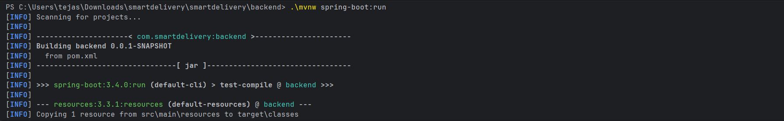

Step 2: Database Schema (MongoDB)
The MongoDB Compass view showing the drivers collection with dynamic fields like currentLat and currentLng.
The MongoDB Compass view showing the drivers collection with dynamic fields like currentLat and currentLng The MongoDB Compass view showing the drivers collection with dynamic fields like currentLat and currentLng
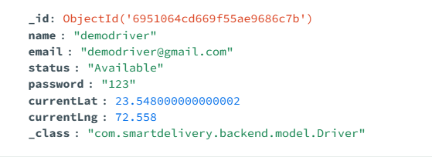

Step 3: API Testing (Postman)
Verifying the Live Tracking endpoint (GET /api/admin/driver-location). The JSON response confirms the driver's coordinates are being fetched correctly
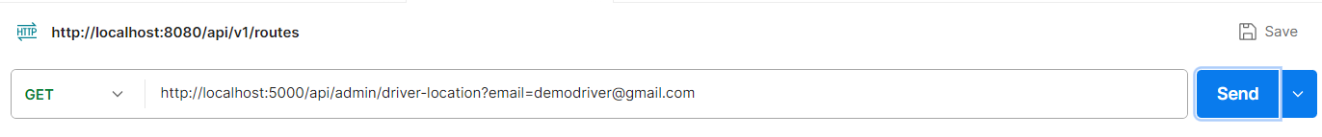

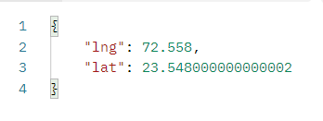

Step 4: Live Tracking in Action
The Admin Dashboard rendering the blue route line based on the data provided by
my backend APIs
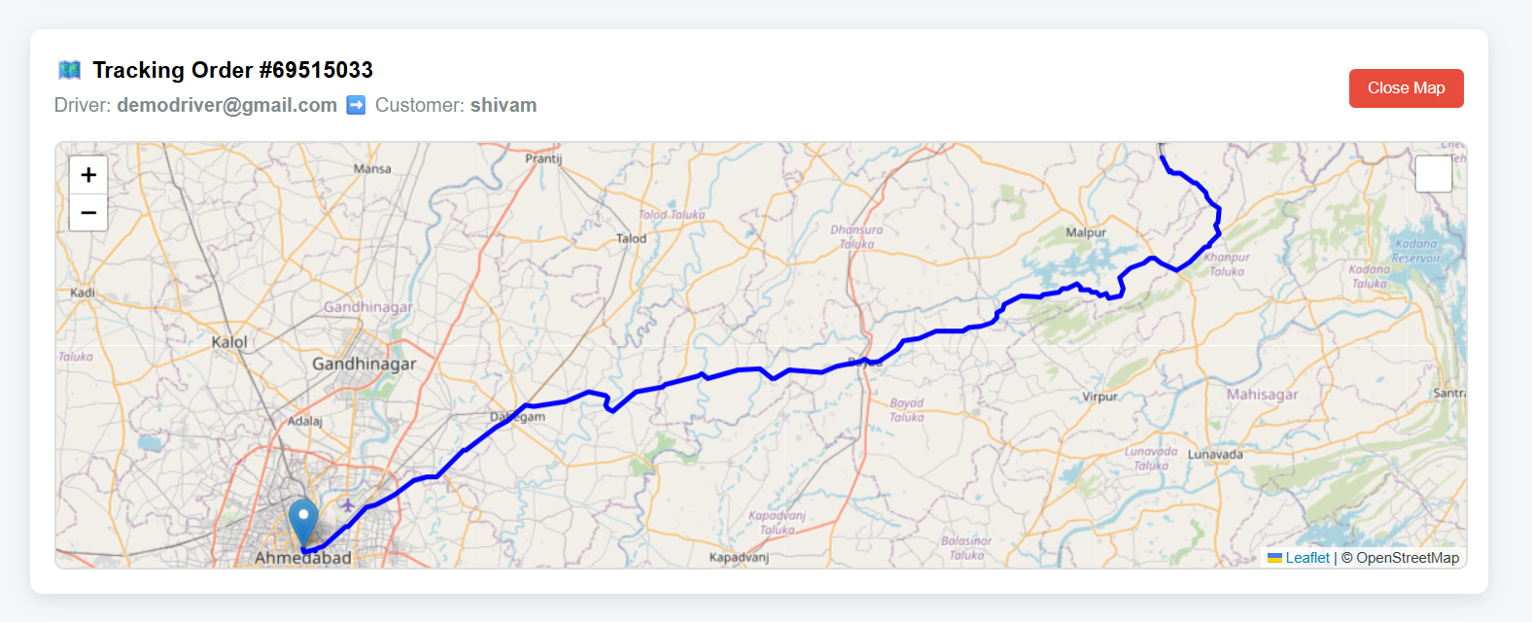

Step 5: AI Performance Report
The backend fetching data and sending it to the Groq API to generate a text-based
Driver review.
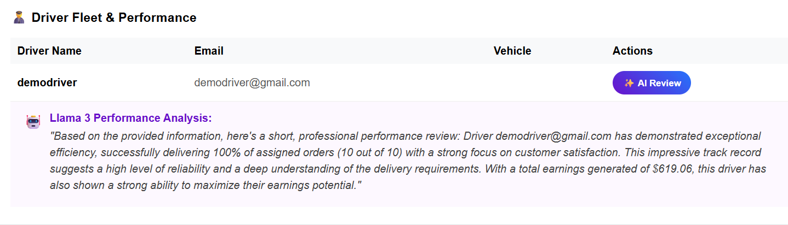

7. Challenges Faced
- Real-Time Latency: Ensuring that the map updated instantly was difficult. I solved this by implementing an optimized Polling Mechanism that refreshes every 5 seconds without overloading the server.
- Data Consistency: Handling the state of an order (e.g., preventing it from jumping from "Assigned" to "Delivered") required strict validation logic in the Service layer.
- Null Pointer Exceptions: Initially, the "Driver Location" API would crash if a driver name didn't match exactly. I implemented robust error handling to search by both Name and Email to fix this.
- CORS Issues: Connecting the React Frontend (Port 3000) to the Java Backend (Port 5000) caused security blocks, which I resolved by configuring Global CORS mapping in Spring Boo

8. Learnings & Skills Acquired
- Backend Architecture: Mastered the Controller-Service-Repository pattern in Spring Boot for building scalable enterprise applications.
- NoSQL Database Management: Gained hands-on experience designing flexible schemas in MongoDB that can adapt to changing data requirements.
- API Engineering: Learned to design industry-standard RESTful APIs with proper HTTP methods (GET/POST) and status codes.
- Live Telemetry Logic: Understood the complexities of handling real-time data streams and synchronizing state between a mobile client and a central server.
- Defensive Programming: improved my ability to write secure code that handles null values and invalid requests gracefully

9. Testimonials from Team
Frontend Lead: "Tejas's backend architecture was the backbone of our project. His well-documented APIs made it incredibly easy for us to connect the React dashboard to the database without worrying about the complex logic behind the scenes."
AI Specialist: "The way Tejas structured the data fetching services allowed me to plug in the Llama 3 model seamlessly. His logic for filtering 'completed orders' was crucial for generating accurate AI performance reports

10. Conclusion
The SmartDeliveryRoute backend has been successfully architected to support a modern delivery tracking application. By leveraging the flexibility of MongoDB and the robustness of Spring Boot, I created a system that is both scalable and maintainable. The separation of concerns through the Controller-Service-Repository pattern ensures that future features, such as route optimization algorithms or notification services, can be added with minimal friction

11. Acknowledgements
I would like to express my sincere gratitude to Infosys Springboard for providing this opportunity to work on the SmartDeliveryRoute project. I am especially thankful to my mentor for their technical guidance on Spring Boot architecture. Finally, I thank my teammates for their collaboration in integrating the frontend and AI components with my backend system.

